Devstack install steps tried as of 2025 – caracal version – ubuntu 22.04:
DevStack — DevStack documentation
Step 0: Install ubuntu 22.04
Do Manual partitioning
  - /boot: 2GB
  - /SWAP: 2*mem (50-60 GB is also fine though)
  - /home: 30GB
  - Optional: 50-100GB partition to store timeshift backups (in my case I created it on 2nd disk which we’ll use for cinder, not os disk)
  - /: rest storage (/var will come in this only)

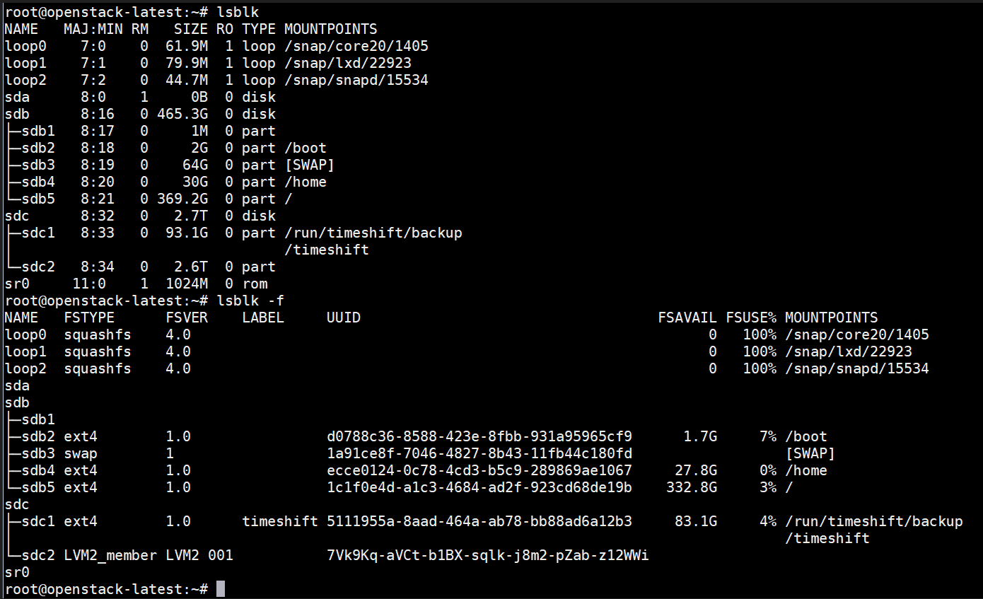
Install timeshift to have a backup snapshot before making any changes, for reverting in case any issues arise. (need separate partition, to store backups)
apt update
apt upgrade -y
apt install timeshift
timeshift --create --snapshot-device /dev/sdc1 --comments "Initial backup" # /dev/sdc1 is the partition I created to store timeshift backups
Step 1: Set up hostname, static IP to the machine and resolve networking issues
# Install and enable NetworkManager
sudo apt install network-manager -y
sudo systemctl enable NetworkManager
sudo systemctl start NetworkManager

# Disable systemd-networkd. Ensure NetworkManager manages all interfaces
sudo systemctl disable systemd-networkd
sudo systemctl stop systemd-networkd
sudo systemctl mask systemd-networkd
sudo systemctl disable systemd-networkd.socket
sudo systemctl mask systemd-networkd.socket
# Netplan also shouldn’t manage. If yaml defines eno1, Netplan will override NetworkManager at boot.
vi /etc/netplan/01-netcfg.yaml
# Replace its contents with:
network:
version: 2
renderer: NetworkManager
sudo netplan apply
#disable cloud-init networking
sudo mkdir -p /etc/cloud/cloud.cfg.d
sudo nano /etc/cloud/cloud.cfg.d/99-disable-networking.cfg
# ADD
network: {config: disabled}

sudo rm -f /etc/NetworkManager/conf.d/*
sudo nano /etc/NetworkManager/conf.d/99-managed.conf
# Add this line to the file:
[keyfile]
unmanaged-devices=none
sudo systemctl restart NetworkManager
reboot

# if eno1 already present in “nmcli con show”
nmcli con delete <uuid>
nmcli con add type ethernet con-name eno1 ifname eno1
sudo nmcli con modify eno1 ipv4.addresses 172.24.29.131/20
sudo nmcli con modify eno1 ipv4.gateway 172.24.16.1
sudo nmcli con modify eno1 ipv4.dns "<dns IPs>"
sudo nmcli con modify eno1 ipv4.dns-search "<dns search suffixes>"
sudo nmcli con modify eno1 ipv4.method manual
sudo nmcli con down eno1 && sudo nmcli con up eno1
reboot
sudo nmcli con down eno1 && sudo nmcli con up eno1

Step 2: Attach >500GB volume and Create a VG named ‘cinder-volumes ‘ on /dev/sdb
# in this case I have 2.6TB VG, so will use 2TB for cinder size in devstack.
pvcreate /dev/sdc2
vgcreate cinder-volumes /dev/sdb

Step 3: Pre-requisites

sudo apt update
apt install -y git lvm2 python3-dev libffi-dev gcc libssl-dev python3-setuptools python3-venv
sudo hostnamectl set-hostname openstack-latest
echo "172.24.29.131 openstack-latest" >> /etc/hosts
sudo systemctl stop ufw
sudo systemctl disable ufw

sudo modprobe vxlan
echo "vxlan" | sudo tee -a /etc/modules

apt install openvswitch-switch

Step 4: Devstack install steps
# Create Stack User
sudo useradd -s /bin/bash -d /opt/stack -m stack
echo "stack ALL=(ALL) NOPASSWD: ALL" | sudo tee /etc/sudoers.d/stack
sudo chmod +x /opt/stack
# clone devstack as stack user
sudo -u stack -i
cd /opt/stack && git clone https://opendev.org/openstack/devstack
cd devstack

vi local.conf
# Add
[[local|localrc]]

# --- General settings ---
GIT_TIMEOUT=600
TRACK_BRANCH=stable/2024.1

# --- Host networking ---
HOST_IP=172.24.29.131
PUBLIC_INTERFACE=eno1
FLOATING_RANGE=172.24.16.0/20
PUBLIC_NETWORK_GATEWAY=172.24.16.1
Q_FLOATING_ALLOCATION_POOL=start=172.24.29.132,end=172.24.29.140
Q_FLOATING_ALLOCATION_POOL+=start=172.24.29.142,end=172.24.29.151

# --- Neutron: skip auto-initial networks ---
NEUTRON_CREATE_INITIAL_NETWORKS=False

# --- Neutron plugin & agent configuration (Open vSwitch) ---
Q_PLUGIN=ml2
Q_AGENT=openvswitch
Q_ML2_PLUGIN_TYPE_DRIVERS=flat,vlan,vxlan
Q_ML2_PLUGIN_MECHANISM_DRIVERS=openvswitch
Q_ML2_TENANT_NETWORK_TYPE=vxlan
ENABLE_TENANT_TUNNELS=True
VXLAN_VNI_RANGES=1001:2000
FLAT_NETWORKS=public
PUBLIC_PHYSICAL_NETWORK=public
Q_USE_PROVIDERNET_FOR_PUBLIC=True

# --- Explicitly enable all Neutron agents ---
ENABLED_SERVICES=q-svc,q-agt,q-dhcp,q-l3,q-meta

# --- Passwords ---
ADMIN_PASSWORD=admin
DATABASE_PASSWORD=$ADMIN_PASSWORD
RABBIT_PASSWORD=$ADMIN_PASSWORD
SERVICE_PASSWORD=$ADMIN_PASSWORD
DATABASE_TYPE=mysql

# --- Horizon dashboard ---
ENABLED_SERVICES+=horizon

# --- Cinder block storage ---
ENABLE_VOLUME=True
VOLUME_GROUP=cinder-volumes
VOLUME_NAME_PREFIX=volume-
CINDER_DRIVER=lvm

# --- Logging ---
LOGFILE=$DEST/logs/stack.sh.log
VERBOSE=True
Step 5: Run Devstack to configure Openstack
Optional: create another timeshift snapshot.
# run devstack script
./stack.sh
# if it fails with unable to download requirements repo due to network timeout, clone the other required repo for devstack manually ensure you use stack user to clone them, not root.
git clone --progress https://opendev.org/openstack/keystone.git /opt/stack/keystone
git clone --progress https://opendev.org/openstack/nova.git /opt/stack/nova
git clone --progress https://opendev.org/openstack/neutron.git /opt/stack/neutron
git clone --progress https://opendev.org/openstack/horizon.git /opt/stack/horizon
git clone --progress https://opendev.org/openstack/cinder.git /opt/stack/cinder
git clone --progress https://opendev.org/openstack/placement.git /opt/stack/placement
git clone --progress https://opendev.org/openstack/requirements.git /opt/stack/requirements
git clone --progress https://opendev.org/openstack/glance.git /opt/stack/glance
# if it fails/hangs. Clone to another machine. Then copy.
git clone https://github.com/openstack/requirements.git C:\requirements
# use 7zip to create tar and then copy to this server
scp -r requirements.tar root@172.24.29.131:/opt/stack
tar -xf requirements.tar

chown -R stack:stack /opt/stack
chmod -R u+rw /opt/stack
# then run script again
./stack.sh

